BEATING COVID SWATCH, COWL AND HAT
beating covid  How to do a Speed Swatch for Fair Isle Knitting, along with a pattern for a Cowl and Hat. | Abstract  Learn a Faire Isle Speed Swatch, then make up a Cowl and Hat to remember how we beat Covid-19!  Virginia Van Osdel  Ginnisueknits Designs

BEATING COVID!
Swatch for Fair Isle Hat/Cowl Project
By Ginnisueknits Designs
For Knerdy Knitters of the SFV

Use DK weight yarn, preferably wool or wool blend. (It sticks together better).
Use 4-6 colors: (Feel free to pick your own colors, just make sure that there is enough contrast)
A-Background, Gray
B- Contrast 1, Medium Green
C-Contrast 2, Light Green
D-Contrast 3, Red
E-Contrast 4, Rose
F-Contrast 5, Navy
Have B and C be a medium and dark of a similar color, D and E be a light and dark of another color. F should be darker than the rest.
Since most Faire Isle patterns are knit in the round, you must knit your swatch in the round. This means that you will always be knitting from right to left, cutting your yarn, and sliding the swatch to the right to start again. DPNs or circular needles will work, straight needles will not.
I used a size 5 needle. Use DPN or circular needle for swatch.
You will need 3 stitch markers and 2 clips to hold the yarn on the sides. I like the red ones to hold the yarn down.
Speed Swatch:
Cast on 36 stitches with Background yarn.
Knit 3 rows, back and forth. The garter stitch border makes it easier to work with the Fair Isle.
FINISH THIS MUCH BEFORE THE CLASS ON THE 29TH SO WE CAN ALL START OFF TOGETHER!
Row 1 and 2: Knit with Color A: *(Add Yarn, Anchor with Clip,) K2, PM, K16, PM, L16, PM, K2, **(Anchor with Clip, cut yarn, slide swatch to the other end of the needle)
Chart 1: With A and F
Row 3: Add Yarn F, *() K2, SM, K16 stitches, SM, K16 stitches, SM, K2**()
Row 4: Knot A and F*(). K2 with both yarns together, SM, *K1A, K1B* to end marker, SM, K2 with both yarns **()
Row 5: With F, *() K2, SM, K16, SM, K16, SM, K2, **()
Row 6 and 7: With A, *() Knit across, moving markers. **()
With Color A, B and C start on Chart 2
Repeat Rows 6 and 7
With Colors A and C start Chart 1
Repeat Rows 6 and 7
With Colors A, D and E start Chart 3
Repeat Rows 6 and 7
With Colors A and C start Chart 1
Repeat Rows 6 and 7
With Colors A, B and C start Chart 2
Repeat Rows 6 and 7
With Colors A and F start Chart 1
Repeat Rows 6 and 7
Garter Stitch 4 Rows and Bind off.
Steam or block your swatch and let dry.

Measure Gauge, if you are content with the colors and the fabric, then you are ready to go on to a cowl or hat with this design.
Abbreviations:
K: Knit
PM: Place Marker
SM: Slip Marker
K1A: Knit one stitch with yarn A
K1B: Knit one stitch with yarn B
CHART 1
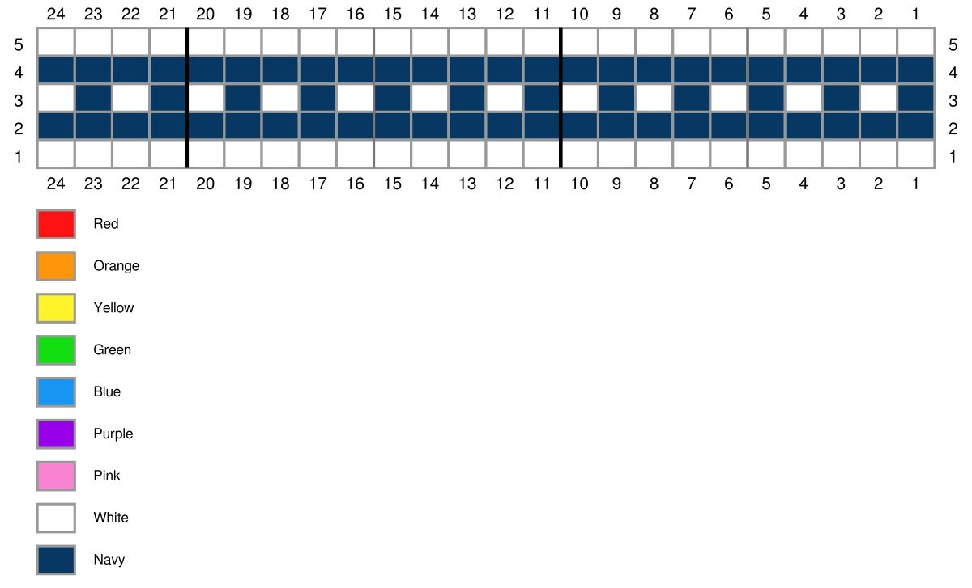
CHART 2
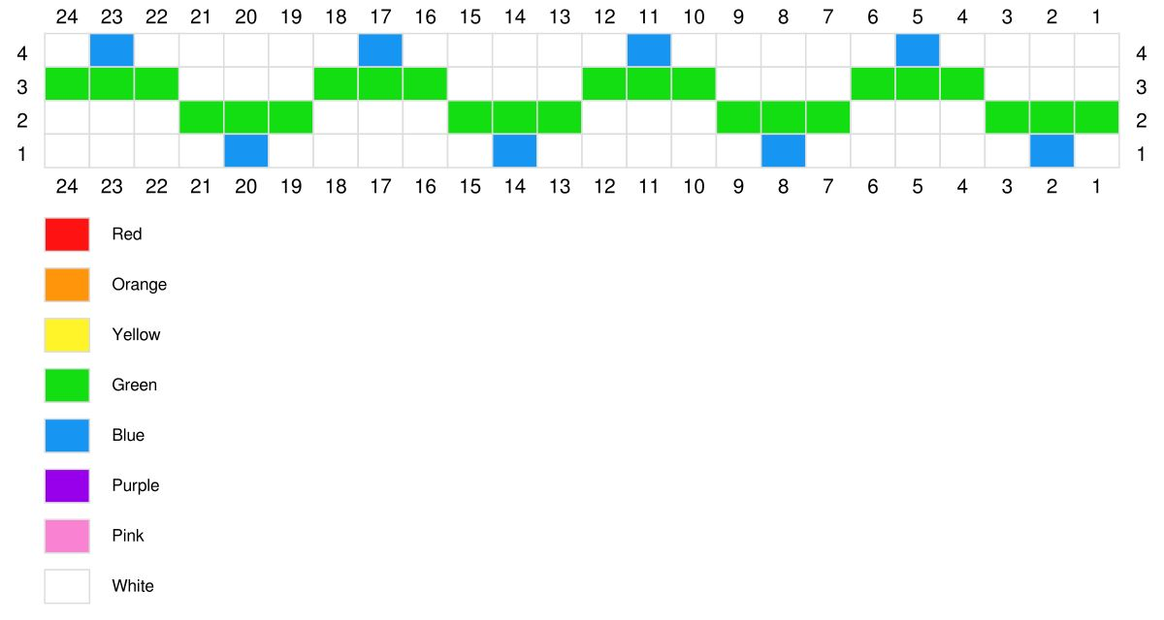

Chart 3:
