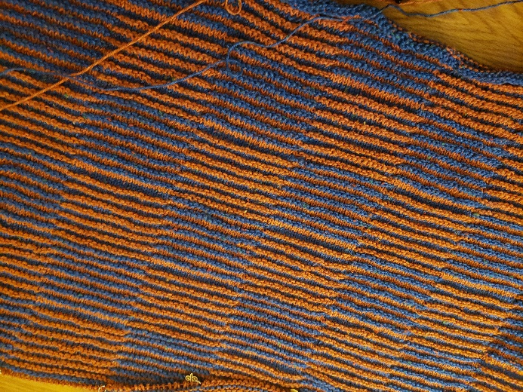
SHADOW KNIT CHECKER-BOARD CHILD’S BLANKET

Yarn
450 yards of two contrasting color, worsted weight yarns
Needles: US 6 or 7

Start with dark color yarn and knit 2 rows. Start pattern on third row (RS).
Design
Row 1 (RS): (All odd number rows): With MC, knit across row.
Row 2 (WS) With MC *P19, K19 repeat from * across. Put markers after each 19 stitches.
Row 3: With CC, K across row.
Row 4: With CC, *K19, P19, repeat from* across row.
Row 5 – 28: Repeat rows 1-4 while keeping in color sequence every other row.
Row 30: With MC, *P19, K19, repeat from * across row.
Row 32: With CC, P19, K19, repeat from * across row.
Row 34: With MC, *K19, P19 repeat from * across row.
Rows 35-58: Repeat rows 31-34, keeping in pattern and color sequence. (Refer to chart)
Repeat the 60 rows until you reach the desired length. I ended with the first color sequence.
Bind off with MC yarn.

